Design Report

1. Preprocess the data provided
2. Build visualizations with matplotlib and seaborn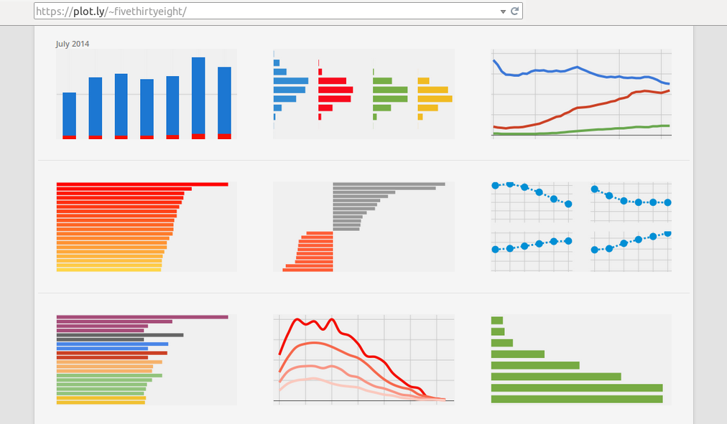
3. Export the graphs in a pdf file.
4. Train and evaluate models using the data provided 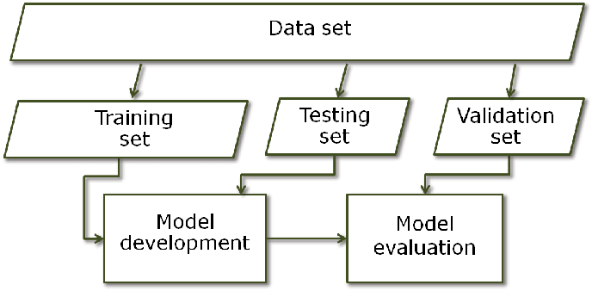
5. Identify the best model
6. Print the F1 score of the best model identified.